React Mobile Developer Assessment

Coding Challenge :

Task :
Implement a small web app that is responsive using Reactjs that list the most starred Github repos created in the last 10 days.

Features :
- As a user, I should see the most starred Github repos that were created in the last 10 days.
- As a user, I should see the results as an item list. One repository should be displayed per row.
- As a user, I should be able to see for each repo the following :
  - Repository name
  - Repository description
  - Numbers of stars for the repo.
  - Username and avatar of the owner.
- As a user, I should be able to scroll and new results should appear (pagination).
How to fetch data from Github –
To get the most starred Github repos in the last 10 days (current date as 2024-07-15), you'll need to call the following endpoint :
https://api.github.com/search/repositories?q=created:>2024-07-15&sort=stars&order=desc
To get the 2nd page, you need to add &page=2
https://api.github.com/search/repositories?q=created:>2024-07-15&sort=stars&order=desc&page=2
and so on for page 3 etc.

Sample Page Output :
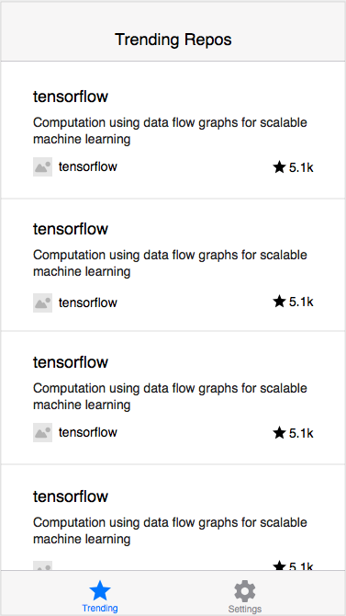

Things to consider while development
- Code quality
- Code structure
- Best practices

***Please push your code to a github repository and share a link***

